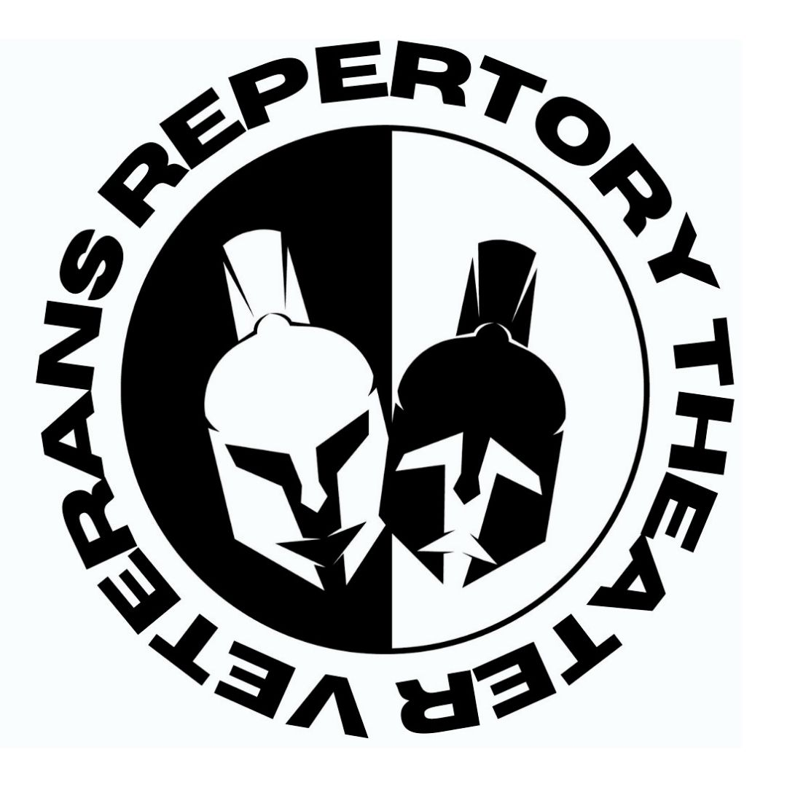

Edie Falco Stars, Bob Balaban Directs Multiple Readings of Brat at Penguin Rep Theatre April 14-16

For release immediately

April 3, 2023 – Penguin Rep Theatre (Joe Brancato, Artistic Director and Andrew M. Horn, Executive Director) and Veterans Repertory Theater (Christopher Paul Meyer, Artistic Director) announce multiple workshop readings of Brat, a new play by Army veteran Jason Pizzarello. The readings take place at Penguin Rep Theatre in Stony Point, NY from April 14-16.

Directed by Bob Balaban (The Exonerated, Gosford Park, The French Dispatch), the readings will star Edie Falco (The Sopranos, Nurse Jackie, Avatar: The Way of Water) and Leonidas Ocampo (Blue Bloods, FBI Most Wanted). Pizzarello is a multiple-times finalist for Arts in the Armed Forces’ Bridge Award and was the winner of VetRep’s 2022 Full-Length Playwriting Competition for Brat.

Set in 2012 and 2016, Brat is a two-person play set in an apartment in Elizabeth, NJ, where a military mother and her neglected, misfit son try to cope with lovers, loss, heartache, and each other before her last deployment and after his first deployment to Afghanistan. Brat captures the fraught relationship between the two as he grows into the soldier she was, mirroring her life in more ways than she wanted for him – including deployments to a multigenerational war in Afghanistan.

Pizzarello said, “Writing Brat was a cathartic experience – because the play is not just about reconciling – it’s about trying to defy history’s attempts to always repeat itself. How do you accept where you came from and who you came from - but transform the results into a better version? How do you escape from the shadow of your parents? Especially with deployments to Afghanistan looming over Brat’s mother-son relationship – Afghanistan being a country with its own seemingly unending cycle. My hope is that everyone can relate to the struggle to break free, evolve, shed baggage - or simply embrace our own actions with all their consequences."

Workshop readings are scheduled Friday, April 14 at 7 p.m., Saturday, April 15 at 3 p.m. and 7 p.m., and Sunday, April 16 at 2 p.m. Seating is limited.

Tickets are $30 ($25 for veterans) and can be purchased online at penguinrep.org or by calling the Penguin box office at (845) 786-2873.

Penguin Rep Theatre is co-producing with Veterans Repertory Theater.

Bios:

Edie Falco (Nora) is best known for her roles as Diane Whittlesey on the HBO series Oz, Carmela Soprano on The Sopranos, and the title role of Showtime’s Nurse Jackie, Edie has received multiple Emmy, Golden Globe, and SAG Awards, as well as the American Film Institute’s Award for Female Television Actor of the Year.

Leonidas Ocampo (Jake) was seen most recently in Water By The Spoonful and Proof with the Heights Players. Originally from Colombia, Leonidas graduated from the U of New Hampshire as a Political Science/ International Affairs major with a minor in Mandarin. After traveling the world he decided to pursue his passion of acting in NYC. He trained at the William Esper Studio. At Columbia he was seen in The Cherry Orchard, and at the Hudson Guild, Julius Caesar. Film: Ferny & Luca, [NY Premiere @ BAM Cinemafest 2022] TV: FBI Most Wanted, Blue Bloods. He is represented by Ivy Rock Management.

Bob Balaban (Director) is an actor, author, comedian, director and producer. He was one of the producers nominated for the Academy Award for Best Picture for Gosford Park, in which he also appeared. He is well known for his appearances in the Christopher Guest comedies Waiting for Guffman, Best in Show, A Mighty Wind, and For Your Consideration, and in the Wes Anderson films Moonrise Kingdom, The Grand Budapest Hotel, Isle of Dogs, and The French Dispatch. Balaban's other film roles include Midnight Cowboy, Close Encounters of the Third Kind, Altered States, and Capote. Balaban has directed three feature films, in addition to numerous television episodes and films.
About Penguin Rep Theatre:

Penguin Rep Theatre (Penguin Players, Ltd.), based in a repurposed 1880s barn in historic Stony Point (Rockland County), New York, is a nonprofit professional theatre company, now in its 45th year of operation, dedicated to promoting new voices and producing new works for the stage.

Integral to Penguin's mission is the development and sharing of enduring stories that offer a wide canvas of emotions, with an emphasis on those that raise awareness of injustice, promote conversation, and offer chances to connect with universal hopes, challenges, and dreams.

Under the dynamic leadership of founding Artistic Director Joe Brancato and executive director Andrew M. Horn, Penguin has become of the mid- Hudson's most enduring nonprofit cultural institutions, reaching tens of thousands of theatergoers each year at its home base, in New York City, and beyond -- with its work moving to Off Broadway and to stages across the country and around the world.

The New York Times has dubbed Penguin "the gutsiest little theatre," and Lohud.com writes that Penguin is “where theatergoers experience magic time after time.”

About Veterans Repertory Theater:

Veterans Repertory Theater is a tax-exempt, non-profit 501c3 organization which provides a platform for talented veterans to create compelling live theater and events. Coming from three generations of theater performers, Army veteran and Bronze Star recipient Christopher Paul Meyer founded VetRep following his separation from the military in February 2021. Through an ongoing series of playwrighting competitions, VetRep assesses, develops, and mentors talented writers who must be current or former military, law enforcement, fire/EMS, foreign service, intelligence service, DoD contractors/employees, or an immediate family member. VetRep’s programming includes weekly staged readings at VetRep’s Parlor in Cornwall, NY, Savage WonderGround immersive art performances at unique venues along the East Coast, the Savage Wonder Festival of Veterans in the Arts, and readings/workshops of veteran-authored world premiere plays, in advance of future productions. VetRep also holds acting and writing workshops in order to develop more veteran artists in each media. VetRep’s popular Savage Wonder literary blog and Savage Wonder podcast are both year-round productions. The literary blog focuses on veteran writers and poets, while the podcast features long-form, one-on-one conversations with veterans in a wide variety of artistic media. Veterans Repertory Theater prides itself on hiring veterans or immediate family members for all staff and leadership positions.

Contact Information:

Andrew M. Horn
Executive Director
andrew@penguinrep.org
(917) 692-5440
penguinrep.org
IG: @penguinreptheatre
FB: @PenguinRep
YouTube: @penguinrepertorytheater7903

Lilla Faint
Managing Director
LF@vetrep.org
(845) 272-2611
vetrep.org
savagewonder.com
IG: @vetreptheater
FB: @veteransrepertorytheater

